4. Check Reconciliation or Check Renumbering

Table of Contents
Check Reconciliation 2
The “General” tab 3
The “Checks” tab 4
Check Renumbering 5

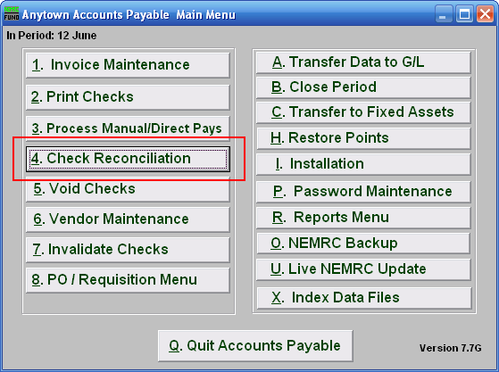
Click on “4. Check Reconciliation” from the Main Menu and the following window will appear.
To Renumber checks, Right-Click on “4. Check Reconciliation” from the Main Menu, and refer to the “Check Renumbering” section below. You will need to print a “1. Check Register Report” from the Reports Menu.

Check Reconciliation

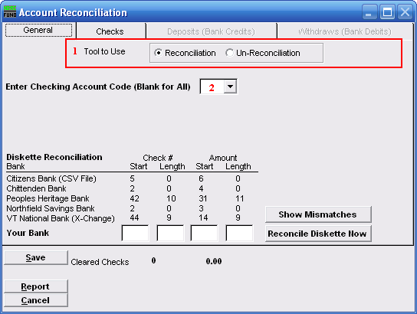
- Tool to Use: Select Reconciliation to record checks that have cleared the bank. Select Un-Reconciliation to change a check that was already reconciled and should not have been. This is often used for electronic checks that need to be re-processed.

- Enter Checking Account Code (Blank for All): Type in the Checking Account Code you wish to use or click on the drop down arrow and choose from there.

The “General” tab

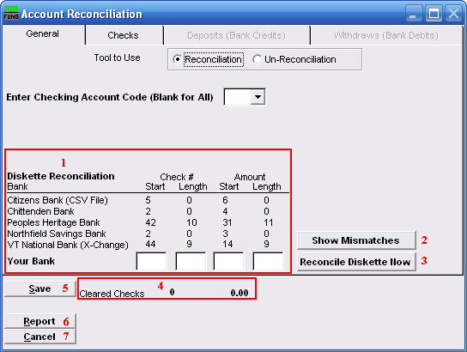
- Diskette Reconciliation: If your bank provides a diskette of cleared checks and you have defined the positions for check numbers and amounts then item 3 will become available. The information will appear here. If you do not have a diskette you will need to go to the checks tab and manually reconcile each individual check.

- Show Mismatches: Click this button after you’ve reconciled to report a list of checks cashed for amounts other than expected or checks cashed that are not on file.

- Reconcile Diskette Now: Click this button after establishing the setting from item 1 to begin processing data from a diskette provided by the bank.

- Cleared Checks: This is informational to track how many have been marked and their total values.

- Save: Click this button to save the reconciliation of checks in the check file.

- Report: Click this button to choose an output option for a report of what you’ve just done.

- Cancel: Click “Cancel” to cancel and return to the previous screen.

The “Checks” tab

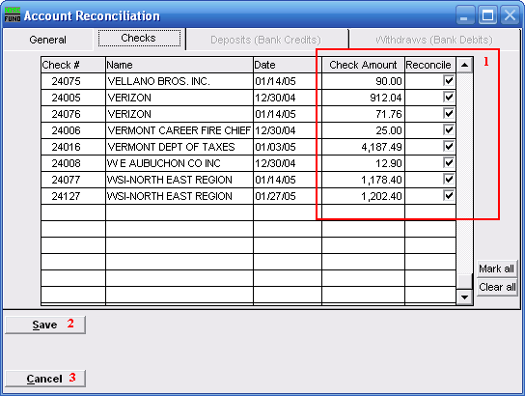
- Reconcile:
To Un-Reconcile: Un-check the box on the detail line for the check to be removed from the reconciliation.
To Reconcile: Check the box on the detail line for the check to be reconciled. If the check was cashed for an amount other then the amount shown, you may click on the “Check Amount” column and adjust the amount accordingly. When reconciling you may wish to go back to the General tab and use the “Show Mismatches” option.

- Save: Click this button to save the changes in the check file.

- Cancel: Click “Cancel” to cancel and return to the Main Menu.

Check Renumbering
To Renumber checks, Right-Click on “4. Check Reconciliation” from the Main Menu and the following window will appear.

You will need the following information from the Check Register Report:

What is the first check number on the register that is incorrect and what should it be?
What is the last number on the register that is incorrect and what should it be?

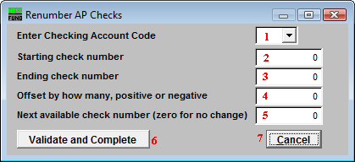
- Enter Checking Account Code: Choose the checking account code that the checks were written from.

- Starting Check Number: Enter the first check number on the register that is incorrect.

- Ending Check Number: Enter the last check number on the check register that is incorrect.

- Offset by how many, positive or negative: The difference between incorrect number and correct number should be entered here. Example: incorrect number is 5010, correct is 5000, difference is on offset of -10.

- Next Available Check Number (zero for no change): What is the next available check number in the box of checks. Whatever you put in this field will be the system default next time you print.

- Validate and Complete: Click “Validate and Complete” to confirm the renumbering.

- Cancel: Click “Cancel” to cancel and return to the Main Menu.

